How to Take Screenshots

Screenshots as Submissions
Much of our work will be completed in other Learning Management Systems (LMS). As a result, students are still required to provide proof of learning and submit to the Brightspace course shell. You are welcome to use whatever screenshot tool you wish, but you must still meet all requirements. This document will only reference a couple of these. Screenshots should display the following:
- An uncropped image of the assignment requirement
- The date and time in the lower right of the computer should be displayed
- Your name should be visible in the screenshot information
- If a dual screen monitor setup is used do not submit a screenshot of both screens, only the window with the results to be taken should be selected
- If a screenshot is being pasted into a document, it should not hang off the margins, and you should resize the image if necessary using the drag function from the lower right corner
- Screenshots should be placed directly below where they were requested in the document
- Do NOT use the PrtScn key to print the entire screen

An example showing the entire screen of one desktop and optional highlight information is shown below
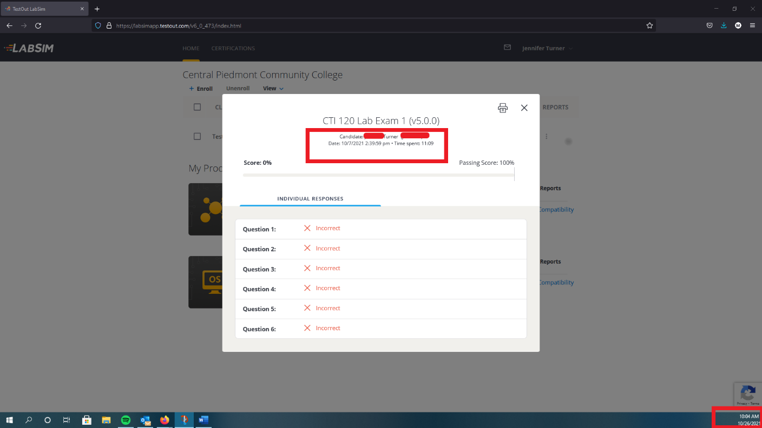
Figure 1- Correct Screenshot Submissions

Using the Windows Snipping Tool for Screenshots
You can capture all or part of your screen, save the image as a snip and paste it directly into a document using screenshot tools in Windows. Depending on your version of Windows will determine what the tool is called and how to utilize it. In Windows 8.1 and earlier versions of Windows 10, the tool you would use is called the Snipping tool. You can capture any of the following types of screenshots:
- Free-form screenshot - Draw a free-form shape around an object.
- Rectangular screenshot - Drag the cursor around an object to form a rectangle. This is the advised method for this class.
- Window screenshot - Select a window, such as a browser window or dialog box that you want to capture.
- Full-screen screenshot - Capture the entire screen. Be advised that if you are using a dual-monitor setup that your screenshot will be very small and will include BOTH desktop screens.
After you capture a screenshot, it's automatically copied to the Snipping Tool window. From there you can annotate, save and/or copy the snip. The following procedures show how to use Snipping Tool.
How to Open Snipping Tool
How you open Snipping Tool is determined by which version of Windows you are using. You may want to right-click on the Snipping Tool and then select Pin to Taskbar or Pin to Start Menu as you will be using this a lot in this class.
- Windows 11: Select the Start button, then click on the Search icon and type “snipping tool” in the search box in the search taskbar, and then select Snipping Tool from the list of results.
- Windows 10: Select the Start button, then type “snipping tool” in the search box in the lower left taskbar, and then select Snipping Tool from the list of results. If you have enabled Cortana, then you may need to click on the Cortana icon at the lower left to access the search box.
- Windows 8.1/RT: Swipe in from the right edge of the screen, tap Search (or if you're using a mouse, point to the lower-right corner of the screen, move the mouse pointer up, and then click Search), type “snipping tool” in the search box, and then select Snipping Tool from the list of results.
- Windows 7: Select the Start button, then type “snipping tool” in the search box, and then select Snipping Tool from the list of results.
How to Take a Screenshot using Snipping Tool
With Snipping Tool started, select Mode (in older versions, select the arrow next to the New button), choose the kind of snip you want, and then select the area of your screen that you want to capture. Remember that you will want to avoid selecting both screens on a dual-monitor setup. Below you will find images for the Snipping tool in both Windows 10 and Windows 11.
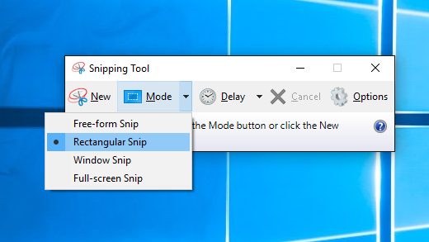

Figure 2- Windows 10 Snipping Tool Options
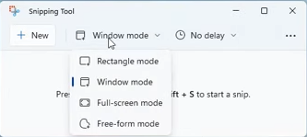
Figure 3- Windows 11 Snipping Tool Options

How to Save a Screenshot
- Annotate a snip: After you capture a screenshot, you can write or draw on or around it by selecting the Pen or Highlighter buttons. Select Eraser to remove the lines you've drawn.
- Save a snip: After you capture a screenshot, right-click on it inside the Snipping Tool window and select the Save As button. In the Save As box type a file name, select a location and type and then select Save.

Snipping Tool Tutorial Video Links
If you still have questions, feel free to watch the video links provided below. Some of the videos may have features that may not be present in your version of Windows:
Windows 11: Windows 11 Snipping Tool Tutorial
Windows 10: Windows 10 Snipping Tool Tutorial

Using the Windows Snip & Sketch Tool for Screenshots
Microsoft replaced the Snipping Tool in some later versions of Windows 10 and replaced it with a different tool. The new tool is a modern take which combines the Snipping Tool and the Screen Sketch tool from Windows 10. This provides you the ability to create sketches on your screenshots after making them. While this is an excellent idea, we will not use the sketch component in our screenshots. You can still capture all or part of your screen, save the image as a snip and paste it directly into a document or save it as a file. You can capture any of the following types of screenshots:
- Snip Now - Drag the cursor around an object to form a rectangle. This is the advised method for this class.
- Snip in 3 Seconds - Select a window, such as a browser window or dialog box that you want to capture, and the snip will occur after 3 seconds have passed.
- Snip in 10 Seconds- Select a window, such as a browser window or dialog box that you want to capture, and the snip will occur after 10 seconds have passed.

After you capture a screenshot, it's automatically copied to the Snip & Sketch window. From there you can annotate or provide highlights to the image for emphasis. After you are finished you can save and/or copy the snip. The following procedures show how to use Snip & Sketch Tool.

How to Open Snip & Sketch Tool
Opening the Snip & Sketch is determined by which version of Windows you are using. You may want to right-click on the Tool and then select Pin to Taskbar or Pin to Start Menu as you will be using this a lot in this class.
- Windows 10: Select the Start button, then type “snip and sketch” in the search box in the lower left taskbar, and then select Snip & Sketch Tool from the list of results. If you have enabled Cortana, then you may need to click on the Cortana icon at the lower left to access the search box.
- Windows 11: Select the Start button, then type “snip and sketch” in the search box in the lower left taskbar, and then select Snip & Sketch Tool from the list of results.
How to Take a Screenshot using Snip & Sketch Tool
With Snip & Sketch Tool started, select the arrow next to the New button, choose the kind of snip you want, and then select the area of your screen that you want to capture. Remember that you will want to avoid selecting both screens on a dual-monitor setup.

Snip & Sketch Tool Tutorial Video Links
If you still have questions, feel free to watch the video links provided below. Some of the videos may have features that may not be present in your version of Windows:
Windows 10/11: Windows 10/11 Snip & Sketch Tool Tutorial

Submitting Screenshots to Brightspace
As discussed earlier, many of our assignments take place outside of Brightspace. Therefore, you will need to submit a completed piece of evidence for learning. In these cases, you will be required to submit a screenshot to Brightspace for grading. Some assignments may require a screenshot of lab steps, in which case they should be pasted into the fields as indicated below. These screenshots will be uploaded in the lab quizzes.
Each lab question will ask for a specific screenshot. Do not add it, insert it, or attach it. I will not be able to see it. If it does not display fully in the area below, but only shows a link with the file name, you will lose points. Do not use the Add File button. You will be placing the screenshot using a different method.
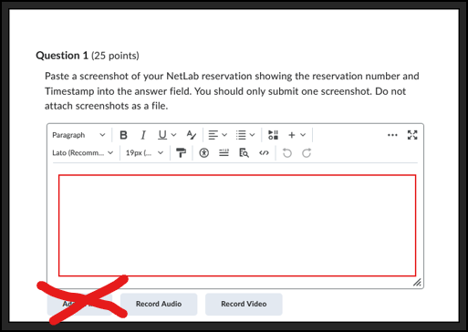
Figure 4- Lab Submission Location
In the toolbar to the right of the Paragraph button click on the down arrow to receive the context menu. Then select the Insert Image selection. From the next menu choose the My Computer option.
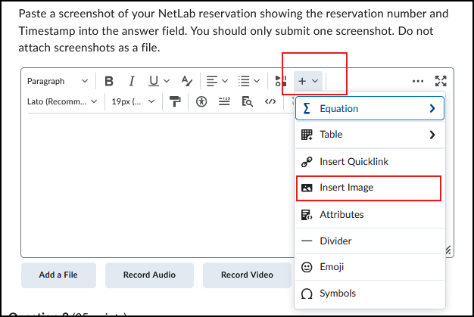
Figure 5- Insert Image Menu Location
Click on the Upload button. From there navigate to the saved location of your image file and select it. Click on the Add as an attachment radio button. (Yes this is the correct attachment type) Then click on the Add button to add the image to the question.
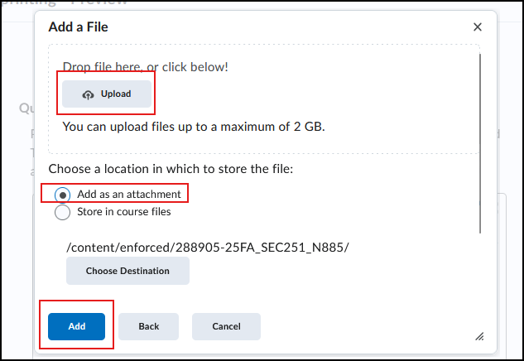
Figure 6- Upload File Location
A Provide Alternative Text dialog will appear. In the This image is decorative location place a check to accept this. Then click on the OK button.
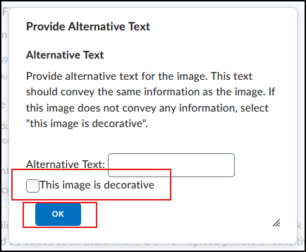
Figure 7- Provide Alternative Text
The image should display in the question field as shown in the next figure. Repeat this process for all other questions. Then submit the quiz. If you need more help please come into the school for assistance or contact your instructor.
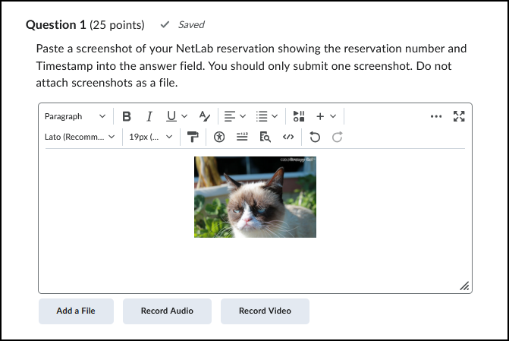
Figure 8- Correct File Submission

